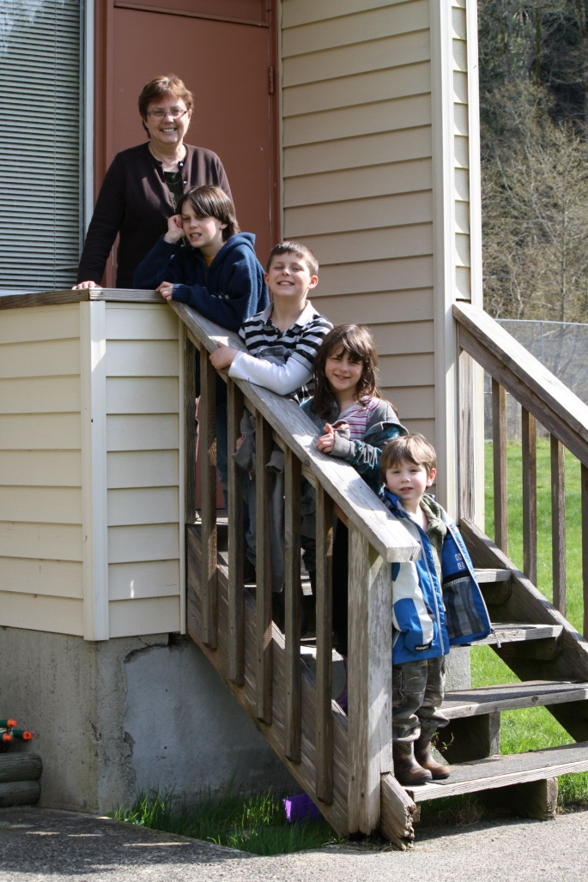

May 24-27: Tuesday to Friday
May 30-June 2: Monday to Thursday



Upcoming Events...

May 28th PAC Bottle Drive

*Sports Day on Galiano

*Bike Rodeo on Mayne Island

June 13th Field Trip to East Point - “Seals” by Athena

June 14th Field Trip to Victoria – Island View
Beach CRD program on crabs and other sea life.

August 15th to 19th - GICEL on Saturna

*See note above
2011 PNE Report Card Ticket Program Update

As we start the next 100 years at Hastings Park, we have decided to change and enhance the existing School Report Card Ticket Program. This new program will allow children to still enjoy this end of summer fun but districts and schools will no longer need to distribute tickets with student report cards. Specific details of this new program will be announced to the public on June 9, 2011 at which time we will send the information release to all districts and schools.

If you have any questions please contact PNE at schooltickets@pne.ca

Congratulations!

We are pleased to announce that our school has been accepted into the BC School Fruit and Vegetable Nutritional Program sponsored by BC Agriculture Foundation and ActNowBC to begin September 2011

Our school is involved in a province-wide initiative. One of the goals is to encourage healthy eating by providing fresh BC fruits and vegetables to the students during classroom time. The students will receive picked, washed and ready to enjoy produce for 13 weeks at no charge!

If your child has an allergy to any fruit or vegetable, please inform the school.

Bicycle Rodeo

We are still finalizing plans for the upcoming Bicycle Rodeo and Sports Day. Dates may be changed but we will let you know well in advance.

